Nursery Home Learning: week commencing 01.03.21
Please choose from the following home learning activities to share and engage with your child. I would love to hear from you and your child, tweet me a video or photos or a short message. I am excited to hear from you.
Mrs Taylor

PE and Music | Remember to have a go at some physical activity each day. A great way to start your day is with the ‘Joe Wicks’ workouts that you can find on Youtube or you may prefer some yoga. Type in the following words on ‘Youtube’  Joe Wicks daily workout  Cosmic Kids Yoga  Can you pick or more of the activities on the link before to take part in?  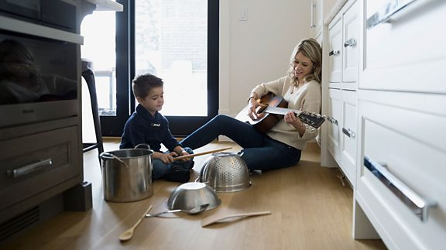  https://www.bbc.co.uk/teach/bring-the-noise/half-term-music-activities/zmmpxyc/  Please share your photos with us on Seesaw or our school Twitter page. We would love to see your daily exercise and music activities.
Reading | Reading  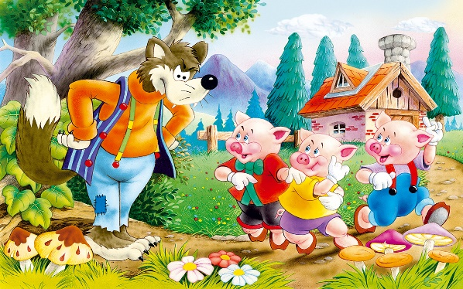  This is the story we will be looking at this week. Click on the link below to access the lessons.  https://classroom.thenational.academy/units/the-three-little-pigs-3ac4  Here is a video that you watch to bring the story to life..  https://www.youtube.com/watch?v=HtHjB6rRmQc  Can you join in with the story?  I would love to see your pictures. Please tweet a picture of you joining in with the story.
Writing | Literacy  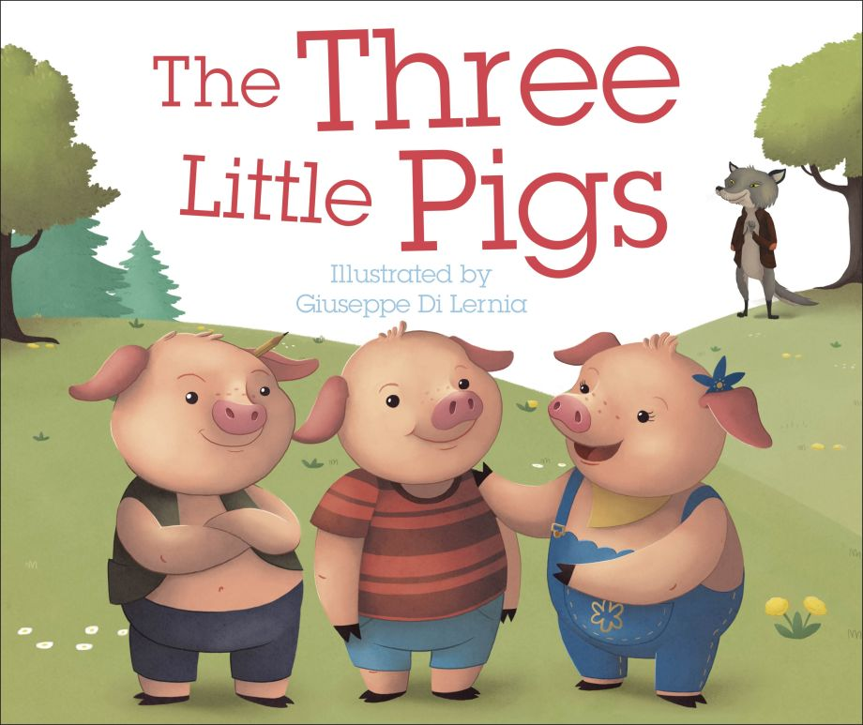  There are a series of lessons/videos posted below that you can use to help with the understanding of the story.  Click on the link below to access the lessons.  https://classroom.thenational.academy/units/the-three-little-pigs-3ac4  Task: Can you draw a picture to show what happens in ‘The Three Little Pigs?’
Phonics | Letters and Sounds  Lesson 1: Loud and Quiet sounds  • Make a loud sound and a quiet sound. • Make a fast sound and a slow sound. • Make a long sound and a short sound.  Let’s have a try at making some sound patterns. Clap a simple rhythm pattern and ask your child to copy.  Lesson 2: Rhyming words  Can you identify which words rhyme?  Lesson 3: Rhyming words continued  Can you put the words in the correct column? You could get your adult to write these on paper for you and read them to you if you can’t print them,
Maths  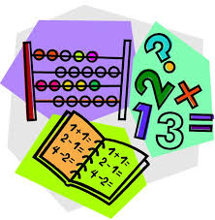 | Here are some websites and links to different songs to support your child with maths at home.  Numberblocks, the BBC television programme has snappy animation and lovable characters. It is great at introducing children to early number.  https://www.bbc.co.uk/iplayer/group/b08bzfnh  Oxford Owl has a range of fun games and activities:  https://home.oxfordowl.co.uk/kids-activities/fun-maths-games-and-activities/  The children love the counting songs from Jack Hartmann as they combine movement with counting. Count to 10 is a favourite.  https://www.youtube.com/watch?v=uGL7xYEVeaY  The children also enjoy Counting to 100:  https://www.youtube.com/watch?v=0TgLtF3PMOc  Everybody Get Up counting song has a catchy tune and attractive graphics:  https://www.youtube.com/watch?v=aKvgwVAGSgw  Shape song:  https://www.youtube.com/watch?v=WTeqUejf3D0  A song about pattern:  https://www.youtube.com/watch?v=BQ9q4U2P3ig  A song about different positions:  https://www.youtube.com/watch?v=idJYhjGyWTU  Day 1 – Number  Can you practise writing your numbers?  Day 2 – Time  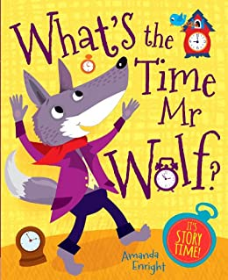  Can you play “What Time Is It, Mr. Wolf?” Use a clock in your house and talk to your child about the different times. Focus on O’clock. Once children are confident with the different times, you could play this game with your family:  How to Play  Choose 1 player to be Mr. Wolf. He stands with his back to the rest of the players lined up at the opposite end of the room.  The players call out, WHAT TIME IS IT, MR. WOLF?  Mr. Wolf shouts out a time between 1 & 12 o’clock.  The number he shouts is the number of steps the players take toward him (for 9 o’clock take 9 steps).  Once the players get close to Mr. Wolf, he shouts LUNCH TIME! and chases them back to the start line.  If a player is caught by Mr. Wolf, that player becomes Mr. Wolf.  Day 3 – Shapes  Go for a walk in the local area to look for the 2D shapes that you can spot in the local buildings. Take some photos and post them on Seesaw to show me what you have found. I can’t wait to see which shapes you find.  Day 4 – Understanding the number 8  This week we are going to focus on the number 8 and the rhyme for  writing this is ‘Make an S and go straight home’ to the tune of ‘Skip to My  Lou’.  This Numberblocks episode teaches you all about the number 8.  Watch the video below :  https://www.bbc.co.uk/cbeebies/watch/numberblocks-the-eight-song?collection=numberblocks-songs  Spiders have 8 legs. Can you draw a picture of a spider with 8 legs? Make sure you count as you draw to check you have the correct number.  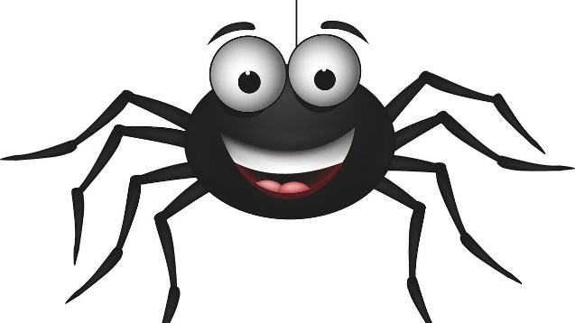  Day 5 –Pattern Challenge!  Look around your house. Can you find any patterns? Can you make up and draw your own repeating pattern?
Collective Worship | See the link for this week’s Collective Worship plan.
Afternoon ideas | Monday - Come and See RE – Gathering : See link on Seesaw  Tuesday – Art/DT – Can you create a house made of sticks, bricks and straw?  Wednesday – Expressive Arts and Design –  Can you make a house for the pigs with blocks/lego or anything you can find and count the amount of blocks you have used to make your house?  Thursday - PSHE –PATHS  Your PATHS activity this week is here.  Can you learn all about 'Twiggle's Special Day'?:  https://barnardosuk.sharefile.eu/share/view/sb35618aac477457a99a709e488bf656a  Here is the worksheet to go with it and some activity ideas:  https://barnardosuk.sharefile.eu/share/view/sb35618aac477457a99a709e488bf656a  Friday – Understanding the World: We are going to be learning about ‘Looking after our Oceans’ this week. Click on the link below to access your lessons: https://classroom.thenational.academy/units/looking-after-our-oceans-1070 In this set of lessons, we learn about ocean pollution. We will identify things that humans do that pollute the ocean. We will then think of things we can do to reduce the pollution in the ocean. At the end of the lesson, we make ocean play dough and practise removing the rubbish from it. Can you make ocean playdough and practise removing rubbish from it? I would love to see a picture of your fabulous work. YYouxnn

