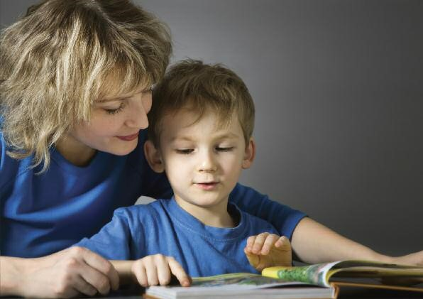
Ten Top Tips for Busy
Mums, Dads and Carers
A Parent’s
Little Guide
to Helping
Children Read
Reading can show you CARE for your child Reading can help you CONNECT with your child Reading can unlock CONFIDENCE in your child.
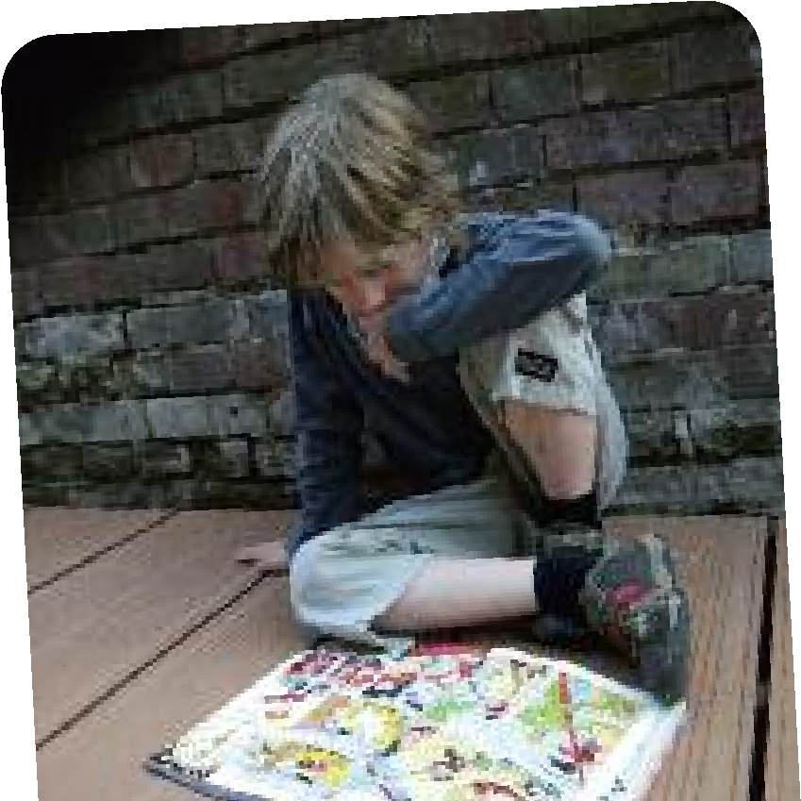
This little guide gives you 10 creative, practical and, most important of all, easy ways to help you help your son or daughter as they start out on the road to enjoying reading for themselves.
R
e
s
e
a
r
c
h

s
h
o
w
s

t
h
a
t

r
e
a
d
i
n
g

t
o

a

y
o
u
n
g
c
h
i
l
d

i
s

t
h
e

s
i
n
g
l
e

m
o
s
t

i
m
p
o
r
t
a
n
t

t
h
i
n
g

y
o
u

c
a
n

d
o

t
o

h
e
l
p

y
o
u
r

c
h
i
l
d
'
s

e
d
u
c
a
t
i
o
n
.

Many mums and dads have discovered that spending just 10 minutes of focussed reading time a day can make a world of difference, not only to your child, but also to YOU!
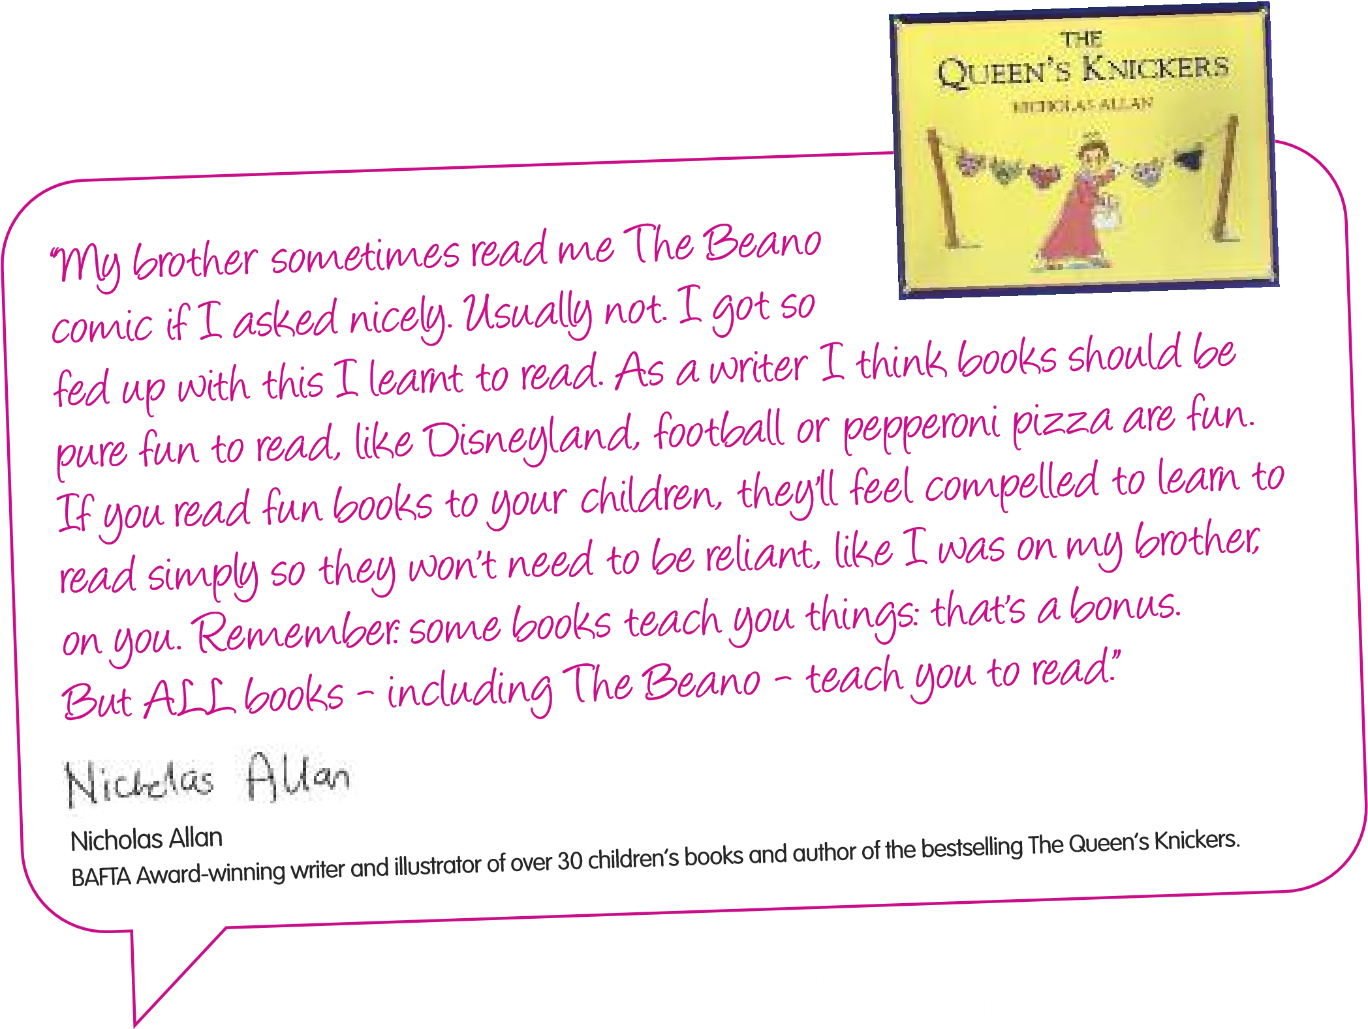

F
O
C
U
S

O
N

W
H
A
T

Y
O
U

C
A
N
D
O
,

N
O
T

W
H
A
T

Y
O
U

C
A
N
’
T

Sometimes as parents it can feel like we’re working flat out just to fit everything in! But remember, although we all find it hard to make the time to read and play with our children, when it comes to reading just a few simple things can make all the difference. There are also lots of places to find advice, tips, and resources.
Why not try:
1
- Talking to your child’s teacher or teaching assistant about their reading. They will have some great ideas and will be keen to help.
- Asking your local library whether they run story telling workshops or if they lend out story tapes or CDs so your child can enjoy listening to stories as they are learning to read.
- Talking to other parents about what books their children like and swapping ideas about what they’ve found works for them.
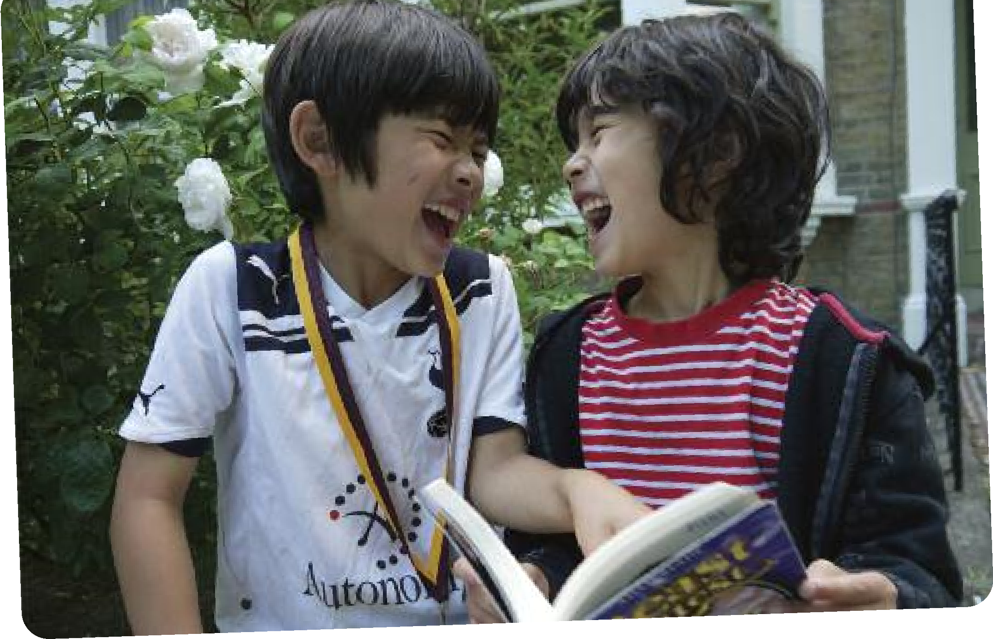
“
W
e

r
e
a
d

t
o

k
n
o
w

t
h
a
t

w
e

a
r
e

n
o
t

a
l
o
n
e
.
”

C
S

L
e
w
i
s
,

a
u
t
h
o
r

o
f

t
h
e

N
a
r
n
i
a

s
e
r
i
e
s

o
f

b
o
o
k
s
.

FIND THE RIGHT LEVEL
2
Many young children struggle with reading because they are introduced to books which are too hard for them. Every child develops at their own speed so try to be patient, looking for stories which give yours just the right level of challenge.
Why not try:
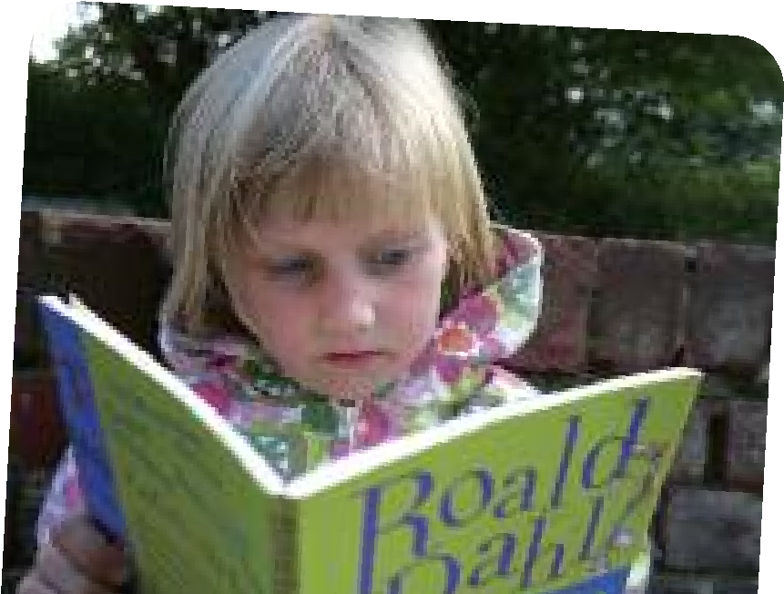
- Encouraging your child to choose a book they want to read – books with pictures are often the best to help them gain confidence.
- Asking your child’s teacher about the types and level of book that will best suit their level of reading.
- Reading harder books to them if they want to hear more complex stories, but letting them read the easy bits.
- Reading their favourite book again and again with them. Repetition helps your son or daughter learn new words.

MAKE A REGULAR TIME TOGETHER
3
Creating a regular ‘special time’ to read together can help younger children see the magical world that can be unlocked by the opening of a book, comic or magazine and learn to love the time when they have your undivided attention.
Why not try:
- Building a regular story time into your child’s bedtime routine.
- Switching off the TV and your mobile to read with them. Resist the urge to tidy their room or do the washing up and give them your time to sit and read together.
- Telling them about a book or story you liked when you were achild. You may still be able to find a copy of it on the internet!
- Making up a story or telling them about when you were a child or something that happened to you at school – remember you don’t always need a book to tell a good story.

TAKE TIME TO LISTEN, LISTEN, LISTEN
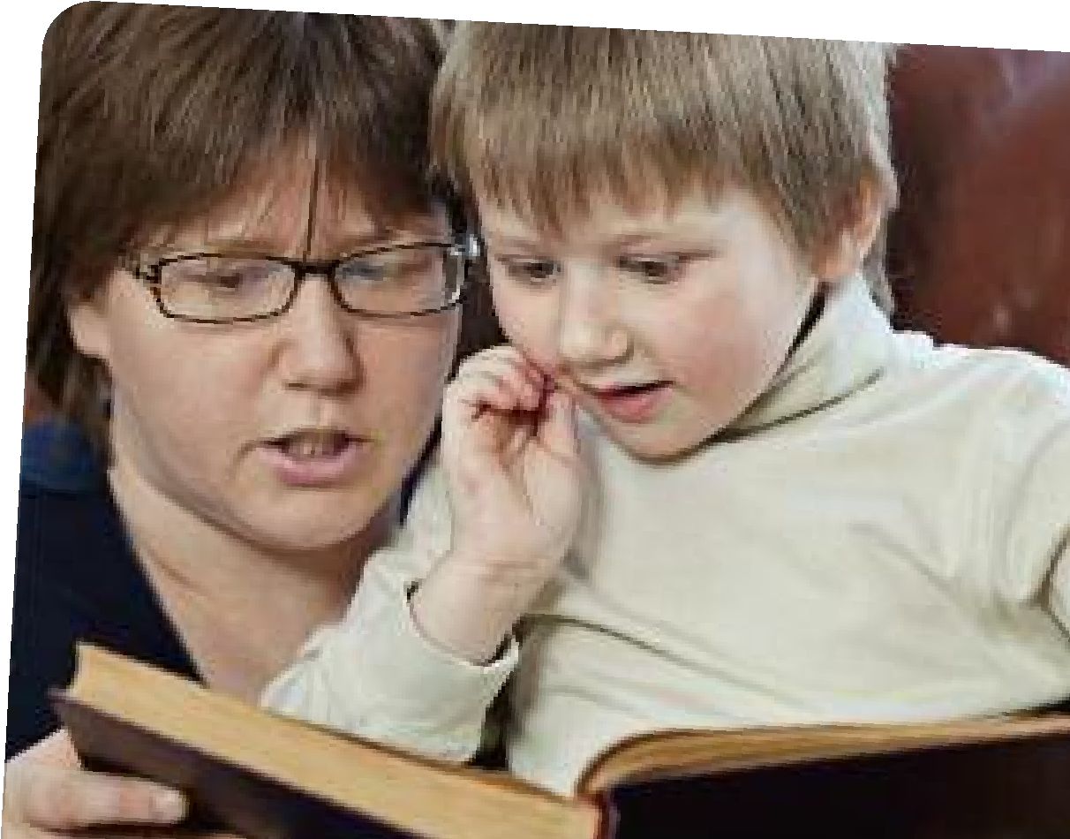
In the middle of a busy day it can be easy to rush reading too, often reading the words for your son or daughter to hurry them along. Try to take time, instead, to really ‘tune in’ to what your child is saying; slowing down to listen to them without interrupting will help them see that you value what they have to say.
T
I
P

4
Why not try:
- Listening with your eyes as well as your ears – giving them your full attention as they talk or read to you.
- Taking it in turns to read parts of the story.
- Telling them one thing you really enjoyabout listening to them read. This will encourage them to do it again.
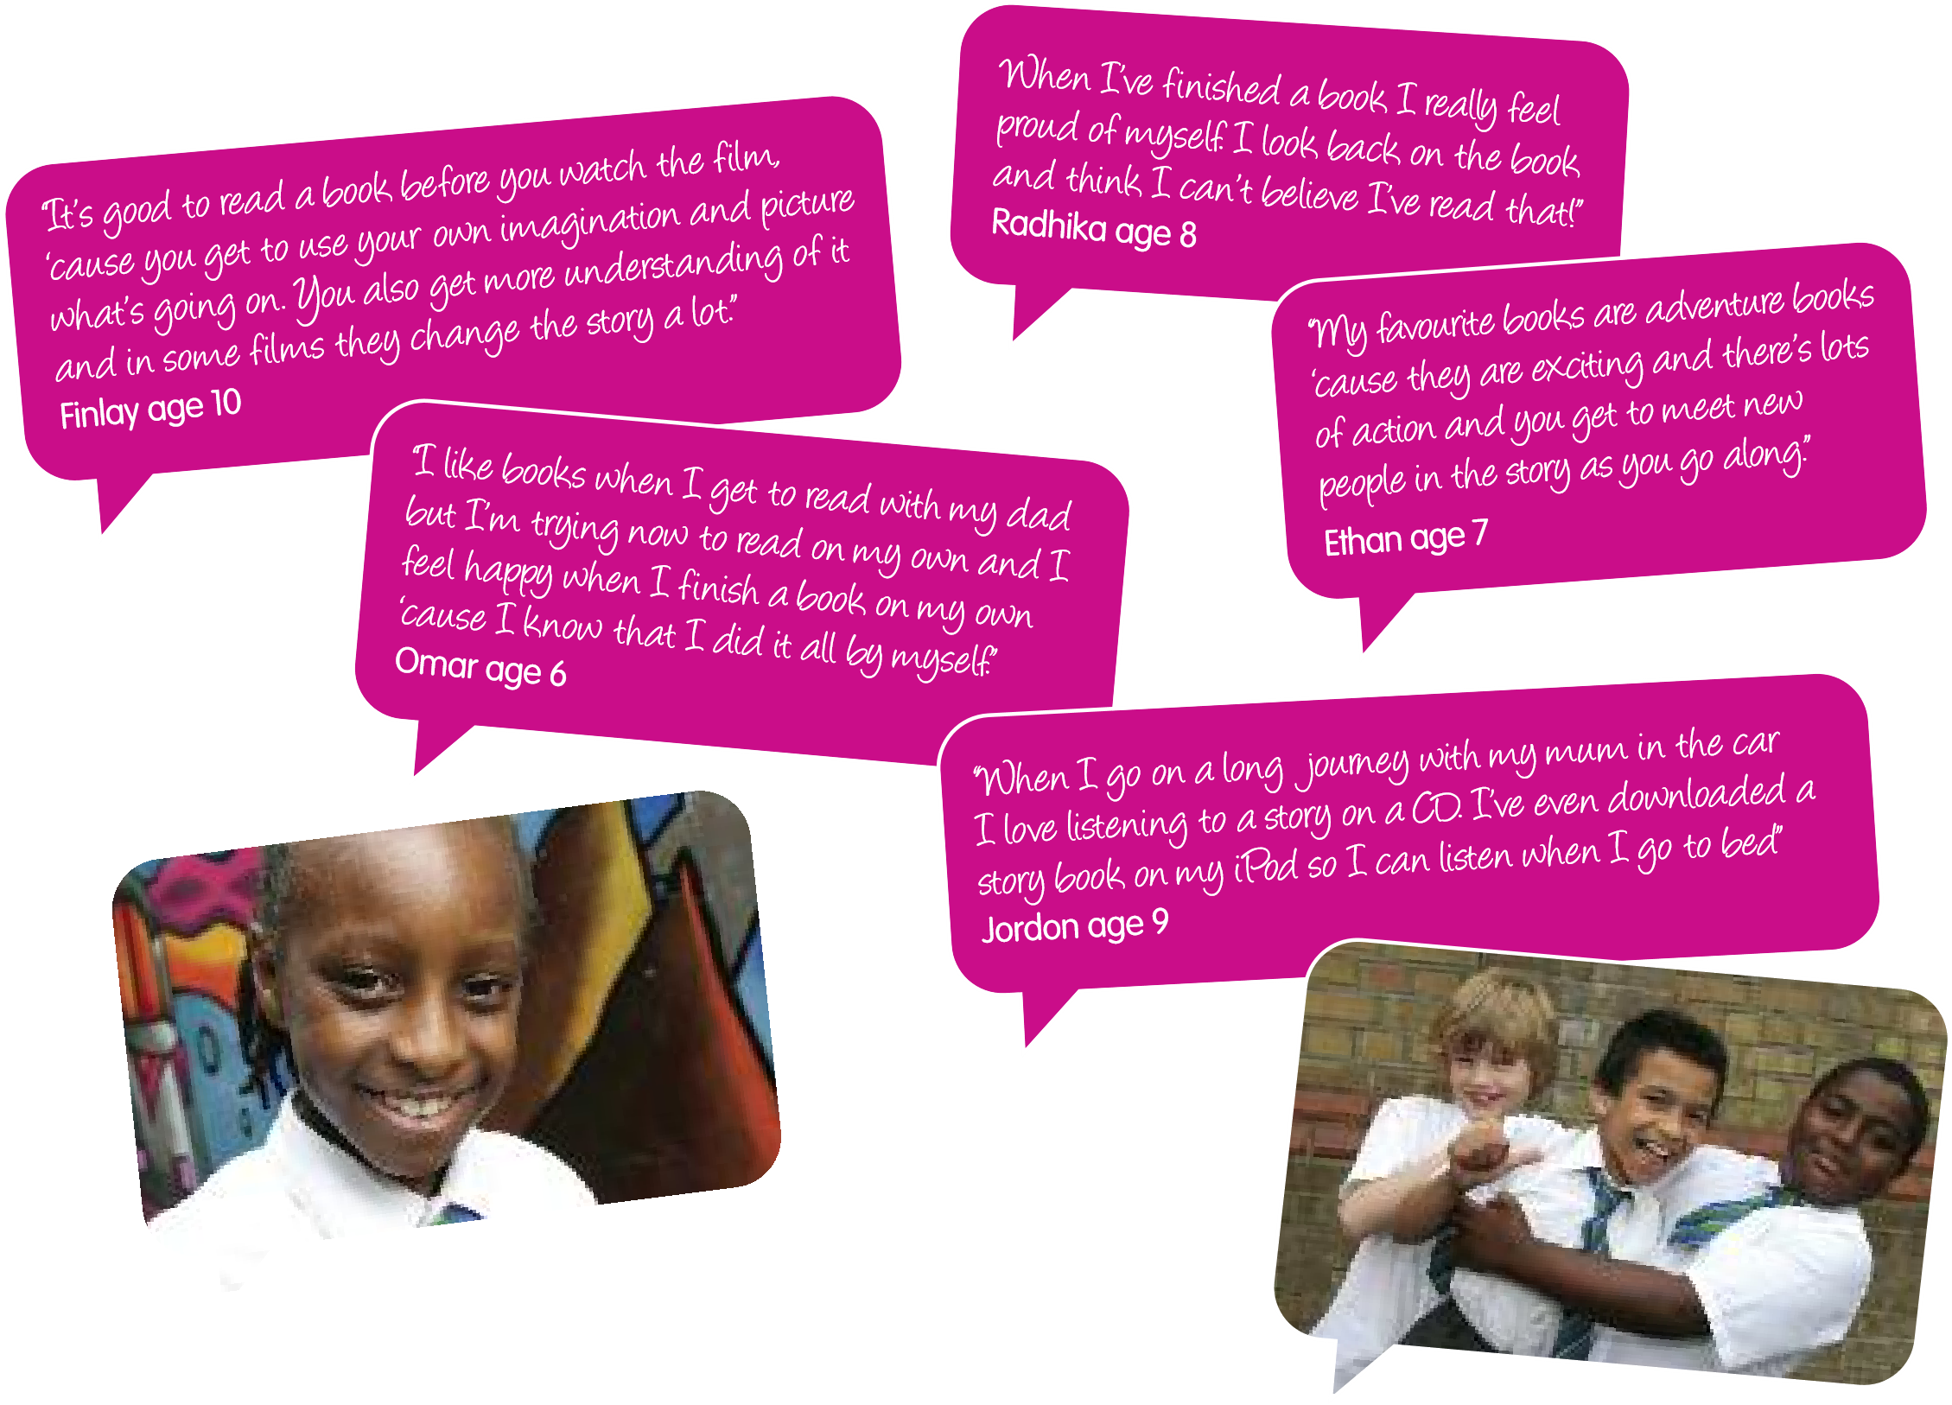

STRIKE A BALANCE BETWEEN PERFECTION AND CONNECTION
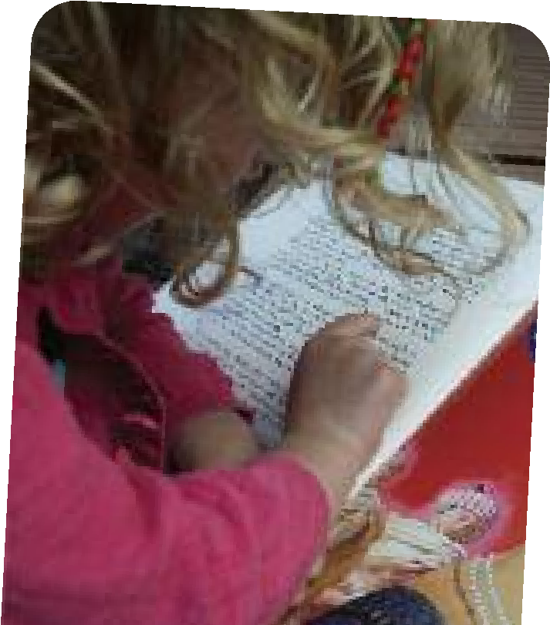
As your child begins to grow in confidence in reading they’re still bound to make mistakes. Get into the habit of praising them for all the words they get right – not just focussing on the ones they are struggling with. At the same time, try to recognise any patterns in the ones they do get wrong and think about the best way to correct mistakes.
T
I
P

5
Why not try:
- Praising them for the words they get right - it really works wonders!
- Looking out for things which will motivate your child to read –instructions on how to enter a competition, make a model or scanning a TV listing to discover when a favourite show is on.
- Making a mental note of any words that your child repeatedly struggles with and spending a few minutes at the start of every reading time trying them out.

TALK ABOUT WHAT YOU’VE READ
Talking about what you’ve just read together helps children think about what they’ve read, boosts their imagination and grows their confidence. It’s also a good way to pick up on new words and check that they understand what they’ve read.
Why not try:
T
I
P

6
- Getting your child to think of questions they can ask you to test if you’ve been listening!
- Asking how they think a particular character in a story might be feeling (you can look at the faces in pictures to help them get started).
- Asking them to tell you what they would do if they were in the story, or what they think is going to happen next. These questions encourage your child to say more than ‘yes’ or ‘no’.

ENJOY READING EVERYWHERE
It doesn’t always have to be a book. Every day there are lots of opportunities for you to encourage your child to get reading.
T
I
P

7
Why not try:
- Going online together and reading or printing off a web page that interests them.
- Carrying a book or comic in your bag to share when you are out and about, on the bus, train, etc.
- Encouraging them to read traffic signs, adverts, cereal packets, simple news headlines, DVD covers or film reviews.

ASK FOR EXTRA HELP IF YOU THINK YOUR CHILD NEEDS IT
It is a staggering fact that around 1 in 5 children reach the age of 11 unable to read confidently. Indeed, it may be that despite all attempts your child still struggles when it comes to reading. This can be a challenge to both the child and their carer but the earlier any problem is spotted the sooner something can be done about it. There are a range of reasons why your child may be struggling but there are a wide range of organisations which can provide support, practical help and specialist advice.
T
I
P

8
Why not try:
- Talking first to your child’s teacher about any concerns you have – they will be able to offer practical advice and options for getting extra help.
- Checking your child’s eye sight. Taking your child to an optician for a free eye test could rule out whether your child has eye tracking problems or sight difficulties.
- Visiting Springboard for Children’s website where we list a range of specialist organisations which can help. www.springboard.org.uk

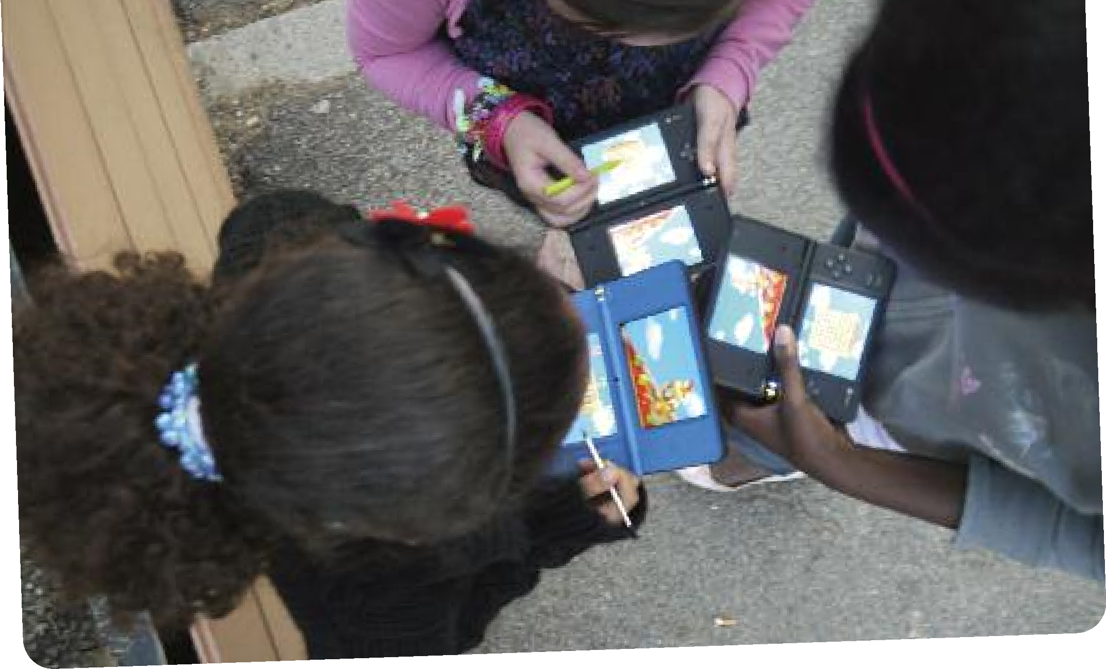
6
“
I
t

a
l
w
a
y
s

a
m
a
z
e
s

m
e

t
o

s
e
e

h
o
w

m
u
c
h

m
y

k
i
d
s

r
e
a
d

w
h
e
n

t
h
e
y

a
r
e

o
n
l
i
n
e

o
r

p
l
a
y
i
n
g

g
a
m
e
s
.

T
h
e
y
’
r
e

r
e
a
l
l
y

m
o
t
i
v
a
t
e
d

t
o

l
e
a
r
n
!
”
C
h
a
r
l
o
t
t
e

–

m
u
m

o
f

3

g
i
r
l
s
.

THINK OUTSIDE THE BOOK!
Never before have children had such access to a range of wonderful creative story and picture books, websites, applications, audio books and mobile devices. E-readers and interactive books are now adding further to the wealth of exciting opportunities for children to read.
However, children still need to ‘crack the code’ by learning the basic building blocks for reading. As your children grow up ask them the kind of things they like to read and ‘how’ they like to read them.
T
I
P

9
Why not try:
- Joining your local library. Not only do they provide access to a huge variety of free books, they alsoprovide DVD’s, audiobooks and even internet access for a small charge. You will need ID to sign up.
- Making a simple book together with pictures they draw or photos they take and help them to write a simple story alongside it.
- Remembering that having fun talking, listening, telling stories and reading together will not only help your son or daughter learn to read but will create memories for you both that will last forever.
HAVE FUN!
Children love it when their parents play with them and praise them. If you have fun reading stories then chances are your child will too! Younger children can have a short attention span so ‘little but often’ might be the best way to keep them motivated and enthusiastic.
Why not try:
- Reading adventure or ghost stories in the dark or under the duvet by torchlight. Try reading the book in a funny accent or breaking up the character parts so you take it in turns to read.
T
I
P
1
0
- Making up a story about your child and all their favourite toys – and use them to act it out.
- Encouraging them to be ‘story detectives’, looking for clues in the pictures and text to help with challenging words.
- Making up a treasure hunt around your home with a clue in every room for your child to find and read.
18
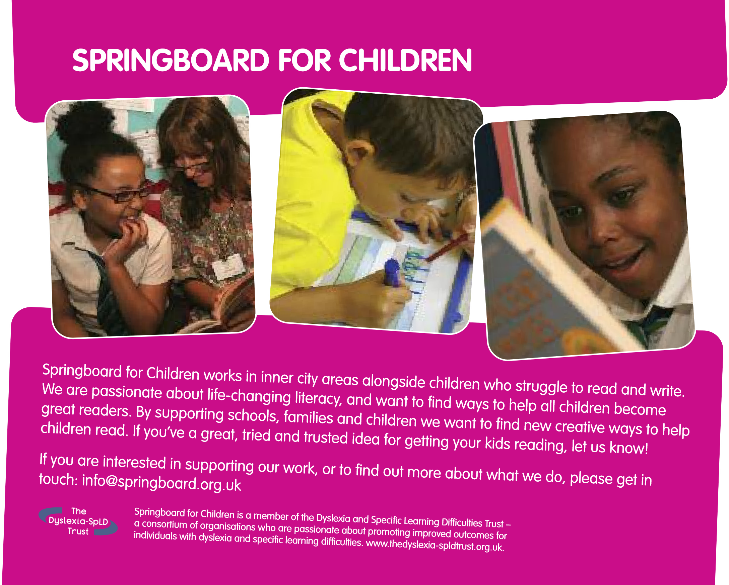
 | a small charge plus posting and packaging.
Polish  Turkish  Bangla  Mandarin  Arabic        | This leaflet is becoming available in other languages and can be downloaded from Springboard.org.uk/parents/languages.  Ulotka będzie dostępna w innych wersjach językowych i możliwa do pobrania z następującej strony: www.springboard.org.uk/parents/languages. Broşürümüz her dilde mevcut olacaktır ve aşağıda adresiverilen web sitemizden talep edilebilir: www.springboard.org.uk/parents/languages ǻ ǽ ǻ  2, XQKǼ^Q@ǺX@Ǻ *NȂWNȂ MǺWSWf JW4fƍ OW^L 2L( +JXI BǻW.I^QWBǻ 6ǽP^Eǻ JWP^LI www.springboard.org.uk/parents/languages 2, XAǹ6ǽWIWf k ǹ ǽ  㗫ᘫිهുᘒظк㊴ㄵẐᘫ䍄߭це www.springboard.org.uk/parents/languages ⢇੥ί㖥  ϊϗϮϤϟ΍ Ϧϣ ΎϬΟ΍ήΨΘγ΍ ϦϜϤϳϭ ϯήΧ΃ ΕΎϐϟ ϲϓ ΓήϓϮΘϣ ϥϮϜΘγ ΓέϮθϨϤϟ΍ ϩάϫ www.springboard.org.uk/parents/languages ϲϧϭήΘϜϟϻ΍  020 7921 4550 Follow us on:  info@springboard.org.uk Springboard for Children www.springboard.org.uk Springboard4  Springboard for Children, The Oasis Centre, 75 Westminster Bridge Road, London SE1 7HS
You can download this publication free of charge at www.springboard.org.uk/parents
Further copies of the booklet are available at
Springboard for Children is a Company Limited by Guarantee (no. 6251103) and a Registered Charity (no. 1124257).
The printing of this publication has been generously sponsored by ‘Wave Design to Print’ - Tel: 01446 700887.

