RED Curriculum Yearly Overview – Nursery to Year 3

Branch 1 | Branch 2 | Branch 3
Creation and covenant | Prophecy and promise | Galilee to Jerusalem
 | 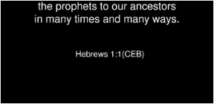 | 
Branch 4 | Branch 5 | Branch 6
Dessert to Garden | To the ends of the earth | Dialogue and Encounter
 |  | 