Y5 Summer Curriculum

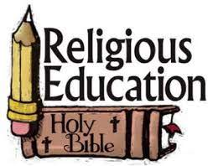 | Y5 themes in RE will be: Domestic Church - God who never stops loving  Transformation- The celebration of the Spirits transforming power.  Freedom and Responsibility – commandments enable Christians to be free and responsible.  Stewardship – The Church is called to the stewardship of creation.
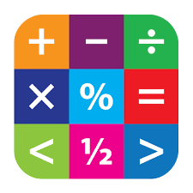 | In Maths Y5 will be furthering their skills in Geometry, Properties of shape, position and direction, and measurement.
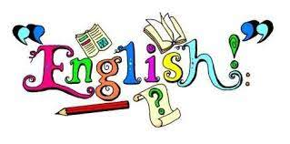 | In English Y5 will have the opportunity to read various texts to extend their skills of understanding, vocabulary & inference.  In writing Y6 will explore texts and have lots of writing opportunities to create a survival narrative, and a dilemma narrative.
 | In Science Y5 are looking at properties and change of materials.
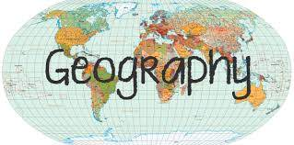 | In Geography and History Y5 will be learning about Andalucía and Civil and Human right icons.
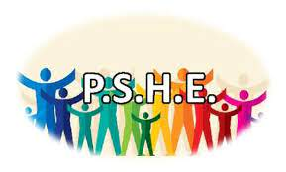 | In PSHE Y5 will be involved with the following:  A Journey in Love– Spiritual  One Decision – Inclusion.  No Outsiders – To explore friendship and to exchange dialogue and express opinion.  Safeguarding- Grassing or grooming (2) and first aid.
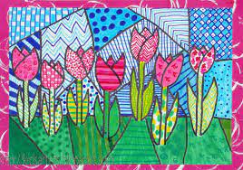 | In Art, Y5 will be looking at artwork from Georgia O’Keefe.
 | In DT Y5 will be investigating food and nutrition.
 | In music Y5 will be focusing on sessions inspired by ‘dancing in the streets’ .
 | In Y5 the children will learn Spanish in the following areas: Hobbies and where; computer related language; and countries, flags and colours.
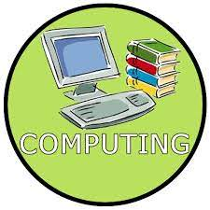 | In Computing Y5 will be learning about Binary messages and investigating Podcaster.
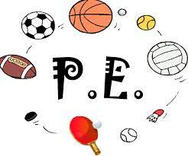 | In PE Y5 are focusing on swimming and athletics.

