Y5 Spring Curriculum

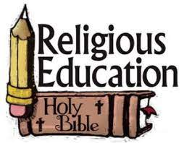 | Y5 themes in RE will be: Domestic Church - God who never stops loving  Mission- Continuing Jesus’ mission in diocese.  Memorial sacrifice- Eucharist as the living memorial of Christ’ sacrifice  Sacrifice- Lent: a time of aligning with the sacrifice made by Jesus.
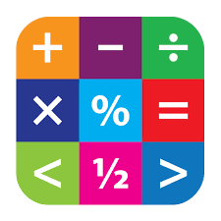 | In Maths Y5 will continue to expand their knowledge in Fractions, Decimals & Percentages.
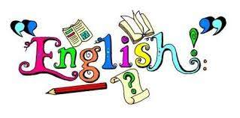 | In English Y5 will have the opportunity to read various texts to extend their skills of understanding, vocabulary & inference.  In writing Y5 will explore texts and have lots of writing opportunities to create a cliff-hanger story, and a character narrative.
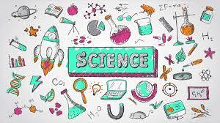 | In Science Y5 are looking at changes from birth to old and life cycles.
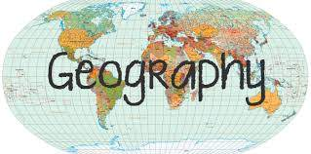 | In Geography and history Y5 will be learning about Victorians & the industrial revolution, and our world in the future.
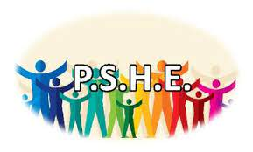 | In PSHE Y5 will be involved with the following:  A Journey In Love– Physical  One Decision –Puberty, Anger, and Image sharing.  No Outsiders- To consider responses to racist behaviour and to recognise when someone needs help.  Safeguarding- Train safety and FGM.
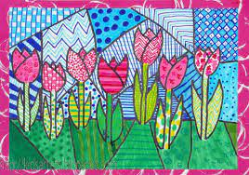 | In Art Y5 will be exploring art work inspired by Lowry.
 | In DT Y5 will be investigating frame structures; creating bird homes and bird feeders.
 | In music Y5 will be focusing on the musician: Bon Jovi.
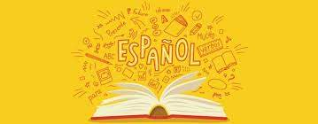 | In Y5 the children will learn Spanish in the following areas: Rooms in house + family members Prepositions and Transport.
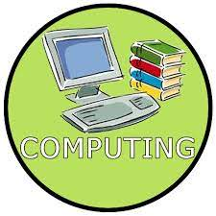 | In Computing Y5 will be exploring video game music composer and my online life.
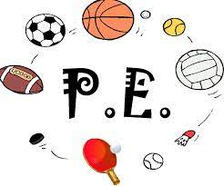 | In PE Y5 are focusing on cricket and Netball.

