Y5 Autumn Curriculum

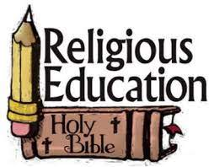 | Y5 themes in RE will be: Domestic Church - God who never stops loving  Ourselves- created in the image and likeness of god  Life choices- marriage, commitment, and service  Hope- Advent: waiting in the joyful hope for Jesus & the promised one
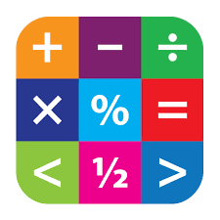 | In Maths Y5 will be extending their skills in the following: Place Value, Addition, Subtraction, and statistics, Multiplication and Division, Perimeter and Area, and Fractions.
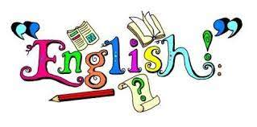 | In English Y5 will have the opportunity to read various texts to extend their skills of understanding, vocabulary & inference.  In writing Y5 will explore texts and have lots of writing opportunities to create an exploration text and a setting narrative.
 | In Science Y6 are looking at Earth and Space, and Forces.
 | In History Y6 will be learning about Ancient Greece.
 | In Geography Y6 will be learning about Trade.
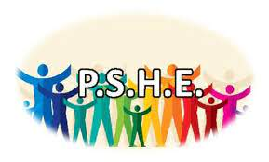 | In PSHE Y6 will be involved with the following:  School council elections & interviews; Class charter; Black History Month & Standing up to discrimination.  Journey in love- Social and emotional  One decision- peer pressure, smoking and looking out for others.  No Outsiders- to consider consequences.
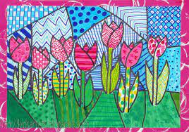 | In Art Y5 will be exploring artwork inspired by Henry Moore.
 | In DT Y5 will be investigating CAD and textiles, combining different material shapes using CAD.
 | In music Y5 will be using glockenspiel percussion instruments to explore rhythm and perform compositions.
 | In Y5 the children will learn Spanish in the following areas: Body parts; Illness; Family members; Clothing; Time; and Counting in 2’s.
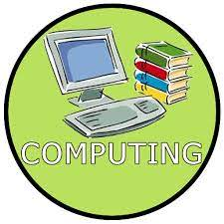 | In Computing Y5 will be looking at Making AR games; STEAM challenges and exploring Youtuber.
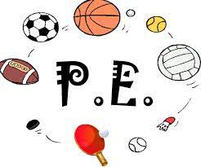 | In PE Y5 will be taking part in Tag rugby and Gymnastics sessions.

