Y6 Autumn Curriculum

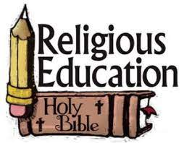 | Y6 themes in RE will be: Domestic Church - God who never stops loving  Baptism/Confirmation - VOCATION AND COMMITMENT - The vocation of priesthood and religious life  Hinduism - Belongings and values  Advent/ Christmas - EXPECTATIONS - Jesus born to show God to the world
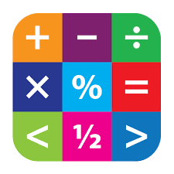 | In Maths Y6 will be extending their skills in the following: Place Value, Addition and Subtraction, Multiplication and Division
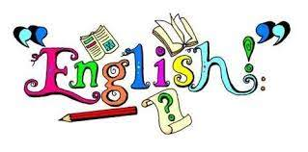 | In English Y6 will have the opportunity to read various texts to extend their skills of understanding, vocabulary & inference.  In writing Y6 will explore texts and have lots of writing opportunities to write a diary entry and a bravery award speech
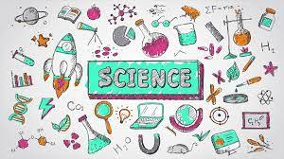 | In Science Y6 are looking at Living Things and their habitats and Animals including humans.
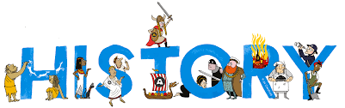 | In History Y6 will be learning about World War Two (the impact on local history) and the Mayans
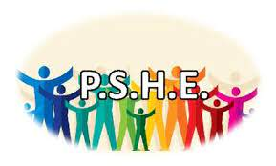 | In PSHE Y6 will be involved with the following:  School council elections & interviews; Class charter; Black History Month & Standing up to discrimination; Promoting diversity; Social relationships; First Aid; Guy Fawkes & Halloween: keeping safe; Rights respecting school activities; water safety; discrimination and British Values
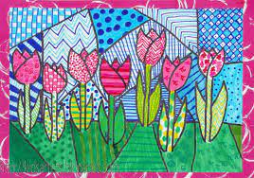 | In Art Y6 will be exploring artwork inspired by Dominic Hinchliffe
 | In DT Y6 will be investigating food and nutrition to celebrate culture and seasonality.
 | In music Y6 will be using recorders to learning “Blown Away”
 | In Y6 the children will learn Spanish in the following areas: Family + job Feelings (hot/cold/thirsty etc) At the doctors (dialogue) Recall 1-100 (x10 – 100 RRP)
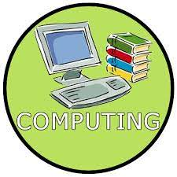 | In Computing Y6 will be looking at Digital Literacy and their online lives and Information technology with VR worlds
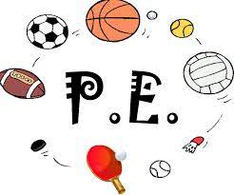 | In PE Y6 will be swimming and learning about water safety.

