Y6 Spring Curriculum

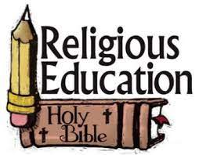 | Y6 themes in RE will be: Domestic Church - God who never stops loving  SOURCES - The Bible, the special book for the Church. UNITY - Eucharist enabling people to live in communion. DEATH & NEW LIFE - Celebrating Jesus’ death and resurrection.
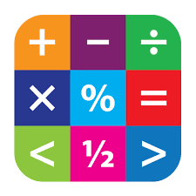 | In Maths Y6 will be extending their skills in decimals, percentages, algebra, measurement and ratio.
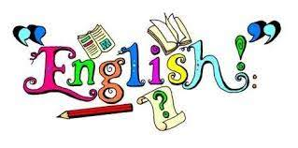 | In English Y6 will have the opportunity to read various texts to extend their skills of understanding, vocabulary & inference.  In writing Y6 will explore texts and have lots of writing opportunities to create classic fiction story, a discussion and an explanation text.
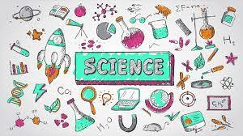 | In Science Y6 are looking at Evolution and inheritance
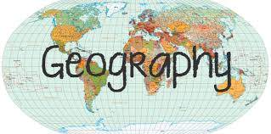 | In Geography Y6 will be learning about climate zones and the Transatlantic Slave Trade
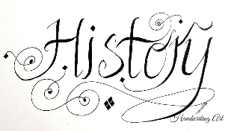 | In History, Y6 will be learning about the Transatlantic Slave Trade
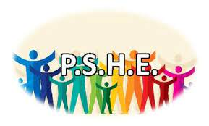 | In PSHE Y6 will be involved with the following:  A Journey In Love– Physical relationships. One Decision – Worry, No Outsiders – To overcome fears about difference, One Decision– Making Friends Online and to consider causes of racism
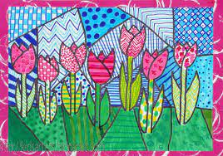 | In Art Y6 will be exploring portraits inspired by Hundertwasser.
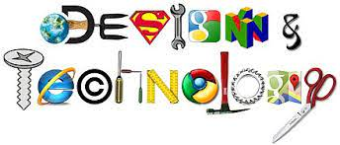 | In DT Y6 will be investigating Fashions and designers over time. They will be making recycled clothes and holding a fashion show
 | In music Y6 will be looking at creative composition
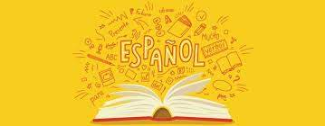 | In Y6 the children will learn Spanish in the following areas: Places in town and directions Round numbers up to 1,000,000 1 1,000 (R/W) Haunted castle mystery Prepositions Counting x2, x3, x5, x10 Fractions and decimals
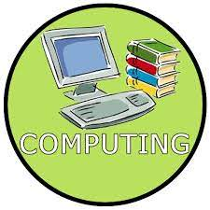 | In Computing Y6 will be looking at Computer science (Crossy Roads) and digital literacy (Online safety dilemmas)
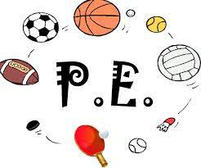 | In PE Y6 are focusing on circuits, and dodgeball

