

Tel: 01744 678319  Email: holycross@sthelens.org.uk  Website: www.holycrossprimarysthelens.co.uk | Charles Street  St. Helens  WA10 1LN  Interim Executive Headteacher:  Miss. Sinéad Walsh  Interim Head of School:  Mr. Alex Platt
Dear Parents/Carers,

Here are the dates for your child’s First Holy Communion preparation this year. Our First Holy Communion for children in Year 4 will be on Saturday 16th May 2026 at 10:00am. Your child must be baptised to make their First Holy Communion, and you will need to provide school with a copy of your child’s baptismal certificate.

If your child is not yet baptised, but you still wish your child to make their First Holy Communion this year, this is possible by attending the two masses listed below at Holy Cross Church:

Saturday 27th September 2025 – Baptism Preparation at 10:00am.
Sunday 28th September 2025 – Baptism at 10:00am.

Between now and May 2026, there will be a total of 18 preparation sessions for the children. Each of these sessions will be held in Holy Cross Church and will be led by Father Jino. All of the dates and times are listed below. You and your child will only need to attend at least 12 of these sessions in order for them to make their First Holy Communion in May. Additionally, you are free to attend any 12 sessions – for example, you could attend Lessons 1 and 2, and then Lessons 4 and 6. We have done this with the aim of greater flexibility for family life. If you do not attend at least twelve sessions between October 25 and May 26, you child will be unable to make their First Holy Communion. We have to keep a register of attendance and share this with Father Jino.

Sunday 12th October 2025 10:00am (Lesson 1)
Sunday 19th October 2025 10:00am (Lesson 2)
Sunday 2nd November 2025 10:00am (Lesson 3)
Sunday 16th November 2025 10:00am (Lesson 4)
Sunday 30th November 2025 10:00am (Lesson 5)
Sunday 14th December 2025 10:00am (Lesson 6)
Sunday 21st December 2025 10:00am (Lesson 7)
Sunday 11th January 2026 10:00am (Lesson 8)
Sunday 18th January 2026 10:00am (Lesson 9)
Sunday 1st February 2026 10:00am (Lesson 10)
Sunday 15th February 2026 10:00am (Lesson 11)
Sunday 1st March 2026 10:00am (Lesson 12)
Sunday 8th March 2026 10:00am (Lesson 13)
Sunday 22nd March 2026 10:00am (Lesson 14)
Sunday 19th April 2026 10:00am (Lesson 15)
Sunday 26th April 2026 10:00am (Lesson 16)
Sunday 3rd May 2026 10:00am (Lesson 17)
Sunday 10th May 2026 10:00am (Lesson 18)

Friday 15th May 2026 (time TBC) = First Holy Communion Preparations and Sacrament of Reconciliation

*On this date, the children will be in school. School staff will take the children to Church on this day.

Saturday 16th May 2026 at 10:00am = First Holy Communion Day

We will be following the ‘I Belong’ preparation program this year and school will buy a copy of this for your child.

We look forward to starting this special journey with our families in Holy Cross and encourage as many of you as possible to put your children forward for their First Holy Communion. Please return the reply slip to the school office no later than Monday 22nd September.

If you have any further questions, please contact the school office.

With very best wishes,
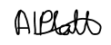
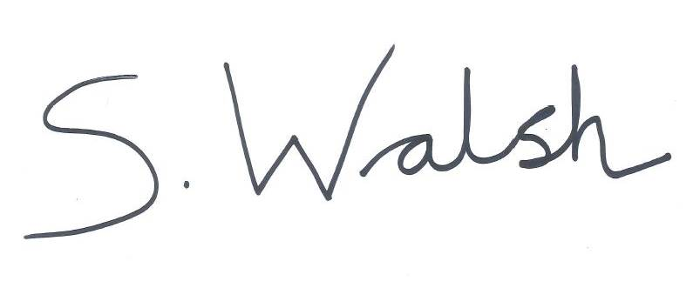
Mr. Alex Platt
Interim Head of School

Miss. Sinéad Walsh
Interim Executive Headteacher

Name of child…………………………………………………………………………………………………………

I wish to put my child forward to make their First Holy Communion on Saturday 16th May 2026.

Signed…………………………………………………………………………………………………………………

Date…………………………………………………………………………………………………………………….

