Helping your child to read A Parent’s Guide

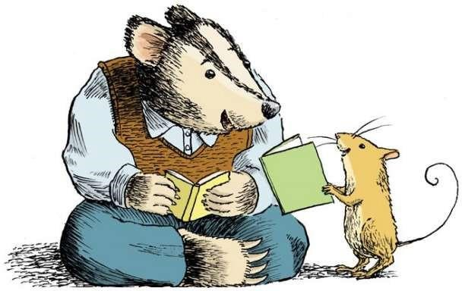
Learning to read does not happen all at once. It involves a series of stages that lead, over time, to independent reading and fluency.
A Beginning Reader likes to look at books and enjoys listening to stories likes to behave like a reader – holding books and pretending to read them begins to look at letter and words and play with them learns about words from songs, rhymes, signs and labels learns how text works – holding a book the right way up, starting at the front of a book, looking left to right in a book uses pictures and memory to tell and retell a story.
An Emerging Reader learns that text is a common way to tell a story or share information begins to match written words to spoken words and recognise relationships between sounds and letters begins to experiment with reading, and is willing to try to say words out loud when reading simple texts finds the pictures helpful in understanding the text, and learns that the words convey a message consistent with the pictures.
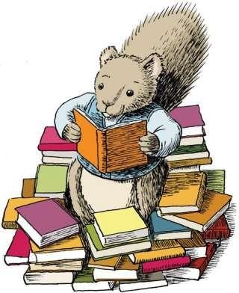
An Early Reader develops more confidence and uses a variety of methods, such as relying on visual cues, to identify words in texts adapts his or her reading to different kinds of texts recognises many words, knows a lot about reading, and is willing to try new texts.
A Fluent Reader uses a variety of methods to identify words and their meanings can read various kinds of texts and predict events in a story can read with appropriate speed and expression relates the meaning of books to his or her own experience and knowledge, and understands what is new.
It's natural to want to compare your child's reading abilities with those of other children of the same age, but not all children develop reading skills at the same pace. What's important is that you are aware of your child's reading level so that you can choose books and activities that will help him or her improve.

Top Tips to Help Your Child with Reading

Talk to Your Child
Here are some things you can do to help your child build an appreciation for words and language:
- Tell family stories.
- Talk to your child about things you are doing and thinking.
- Ask your child questions and encourage them to do the same.
- Encourage your child to tell you what he or she thinks or feels.
- Ask your child to tell you about his or her day.
- Be patient!
- Give your child time to find the words they want to use.
- Sing songs and recite nursery rhymes with your child. ✓ Play rhyming games.

Make Reading Fun
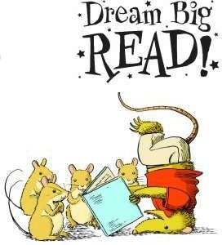
Reading aloud to children is the best way to get them interested in reading and can be lots of fun! Here are some ways to get the most out of reading to your young child:
- Read with drama and excitement! Use different voices for different characters in the story.
- Re-read your child's favourite stories as many times as your child wants to hear them, and choose books and authors that your child enjoys.
- Read stories that have repetitive parts and encourage your child to join in. Point to words as you read them. This will help your child make a connection between the words he or she hears you say and the words on the page.
- Read all kinds of material – stories, poems, information books and comics.
- Take your child to the library.
- Look at digital texts, lots available at http://www.oxfordowl.co.uk

Read Every Day
Children love routine, and reading is something that you and your child can look forward to every day. By taking the time to read with your child, you show him or her that reading is important. Try to read with your child as often as possible. It's the best thing you can do to help him or her learn at school!
- Set aside a special time each day when you can give your full attention to reading with your child.
- Choose a comfortable spot to read, where you can be close to your child.
- Share a variety of books.
- Read slowly so that your child can form a mental picture of what is happening in the story.
- Encourage your child to participate.
- Keep reading to your child even after he or she has learned to read.

By reading stories that will interest your child but that are above his or her reading level, you can stretch your child's understanding and keep alive the magic of shared reading.

Set an Example
As a parent, you are your child's most important role model. If your child sees you reading, especially for pleasure or information, he or she will understand that reading is a worthwhile activity. You can share many daily reading activities with your child. Here are some ideas:
- Read recipes, food labels, schedules, maps, instructions, and brochures.
- Read traffic signs and signs in stores and restaurants.
- Look up information in cookbooks, manuals, phone books, atlases, and dictionaries.
- Read greeting cards, letters, and e-mail messages to and from relatives and friends.

Talk About Books
Talking about the books you read is just as important as reading them. Discussing a story or a book with your child helps your child understand it and connect it to his or her own experience of life. It can also help enrich your child's vocabulary with new words and phrases. Here are some ways to help your child acquire skills in comprehension, reasoning, and critical thinking:
- Ask your child about the kinds of books he or she would like to read.
- Talk to your child about your favourite books from childhood, and maybe read them.
- Encourage your child to ask questions and comment on the story and pictures in a book – before, during, and after reading it.

